Air Quality Trends and Pollution Analysis in Indian Cities
Internship / Training Project Report

Prepared by
Akhil.M
B.Tech — Artificial Intelligence and Data Science
Second Year | VSB Engineering College
Internship Organization: Next Gen Software Hub
Prepared using Python, pandas, NumPy, Matplotlib and Seaborn

Abstract
This project analyzes the Air Quality Data in India dataset covering daily city-level observations from 1 January 2015 to 1 July 2020. The inspected file contains 29,531 rows and 16 columns across 26 cities. The workflow includes data inspection, conservative cleaning, exploratory analysis, yearly summaries, a comparison restricted to cities represented in every year from 2015–2019, and pollutant–AQI correlation analysis. Ahmedabad had the highest average recorded AQI among the cities in the reported ranking (452.12). PM10 had the strongest correlation with AQI among the selected pollutants (r ≈ 0.80). These are descriptive findings for the available dataset, not proof of causation or a complete measure of air quality across India.

1. Introduction
Air quality is an important environmental issue because concentrations of particulate matter and gases can vary by location and time. This project uses recorded city-level observations to explore differences in AQI, category distribution, year-to-year summaries, and relationships between selected pollutants and AQI. The goal is to apply a transparent, reproducible data-analysis workflow rather than to make causal or policy claims.

2. Objectives
- Inspect the dataset structure, coverage, and missing values.
- Prepare a cleaned working copy while preserving the source data.
- Compare average recorded AQI across cities and examine AQI category counts.
- Summarize AQI by year and compare a consistent set of cities over 2015–2019.
- Measure correlations between selected pollutants and AQI.
- Document limitations and make the analysis reproducible.

3. Dataset Description
The analysis uses the city_day.csv file from the Air Quality Data in India dataset. The initial inspection found 29,531 rows and 16 columns, covering 26 cities from 2015-01-01 through 2020-07-01.
Item | Description
Dataset | Air Quality Data in India (city_day.csv)
Coverage | 2015-01-01 to 2020-07-01
Records / fields | 29,531 rows / 16 columns
Cities | 26
Key fields | City, Date, pollutant measurements, AQI, AQI_Bucket
Source URL | https://www.kaggle.com/datasets/rohanrao/air-quality-data-in-india
Dataset source: https://www.kaggle.com/datasets/rohanrao/air-quality-data-in-india
Publication note: verify the dataset page's current license and attribution requirements before sharing the source data or publishing the repository. This report summarizes the user's analysis results; the source CSV is not embedded.

4. Tools and Technologies
Python 3.14.7; pandas for tabular processing; NumPy for numerical operations; Matplotlib and Seaborn for visual analysis; CSV outputs for reusable summaries.

5. Methodology
1. Inspection: Loaded the CSV with pandas, checked dimensions, columns, date range, city coverage, and missing-value counts.
2. Cleaning: Parsed Date, checked duplicate City–Date combinations and negative numeric values, removed rows only if City or Date was missing, sorted by City and Date, and saved a separate cleaned CSV. The original data was not overwritten.
3. Exploratory analysis: Calculated city-level average AQI, monthly average AQI, and AQI category counts; generated charts and CSV summaries.
4. Yearly analysis: Calculated yearly summaries. Because city coverage changes by year and 2020 is partial, the broad yearly summary is treated cautiously.
5. Fair comparison: Restricted the 2015–2019 comparison to the seven cities present in all five years.
6. Correlation: Calculated pairwise correlations for selected pollutants and AQI using available observations; pairwise sample counts were also exported.

6. Data Quality and Missing Values
No duplicate City–Date combinations or negative values were found in the checked numeric columns. Missing values were not filled automatically, because imputation can change distributions and results. The most notable missingness counts were:
Field | Missing values | Missing %
Xylene | 18,109 | 61.32%
PM10 | 11,140 | 37.72%
NH3 | 10,328 | 34.97%
Toluene | 8,041 | 27.23%
Benzene | 5,623 | 19.04%
AQI / AQI_Bucket | 4,681 each | 15.85%
PM2.5 | 4,598 | 15.57%
The cleaning step preserved the dataset's missing values and wrote a separate cleaned copy, leaving the original dataset unchanged.

7. Results and Discussion

7.1 City comparison
Ahmedabad had the highest average recorded AQI in the reported top-ten ranking (452.12), followed by Delhi (259.49), Patna (240.78), Gurugram (225.12), and Lucknow (217.97). These averages are based on available AQI records; differing coverage and missing observations should be considered when comparing cities.
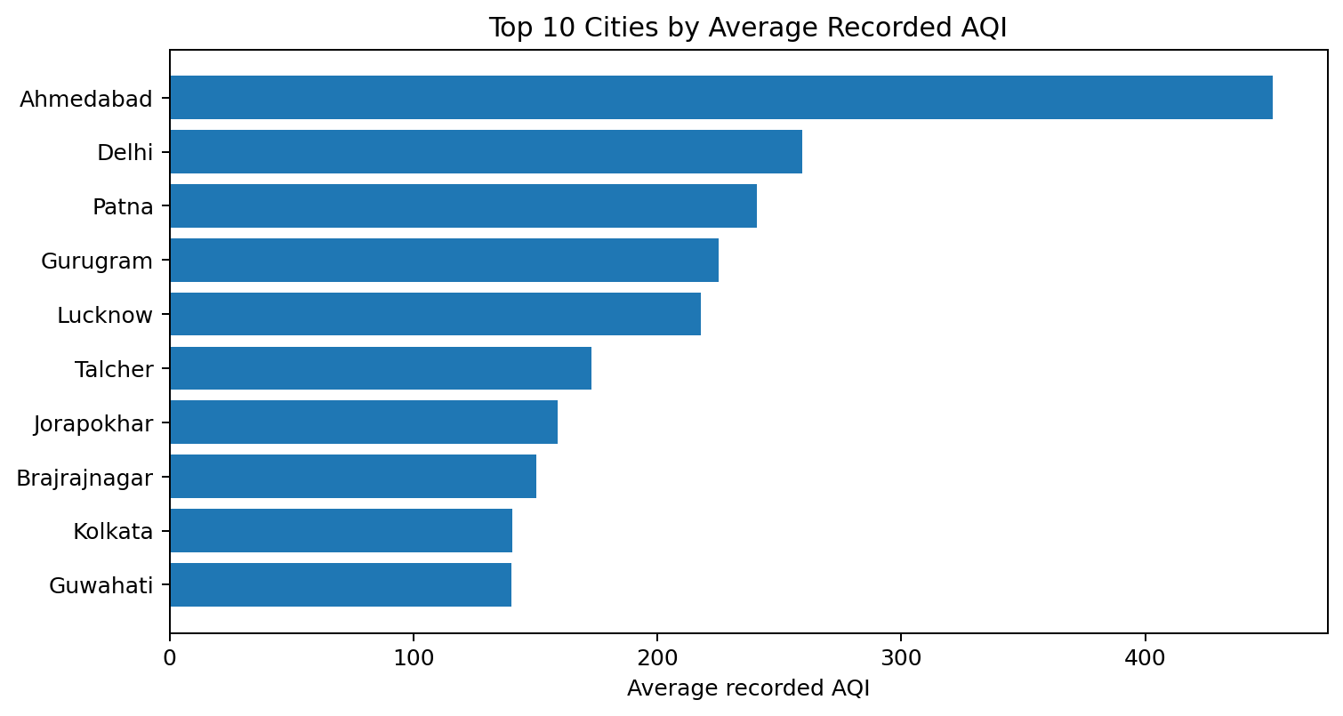
Figure 1. Top ten cities by average recorded AQI.

7.2 AQI category distribution
There were 24,850 records with an AQI value/category. Moderate represented 8,829 records (35.53%) and Satisfactory represented 8,224 (33.10%). Poor, Very Poor, and Severe together represented approximately 26.0% of categorized records.
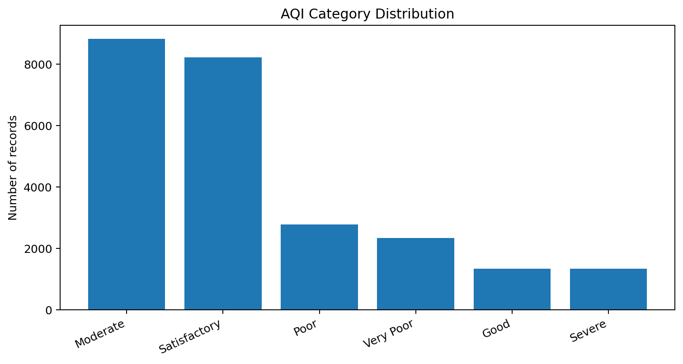
Figure 2. Counts by AQI category.

7.3 Yearly summary and comparability
The reported mean of city-level annual AQI averages was 223.58 in 2015, 200.66 in 2016, 203.03 in 2017, 179.27 in 2018, 150.23 in 2019, and 112.24 in 2020. However, the number of represented cities increased from 7 in 2015 to 26 in 2020, and 2020 contains only data through 1 July. These values are therefore not a fair stand-alone measure of nationwide change.
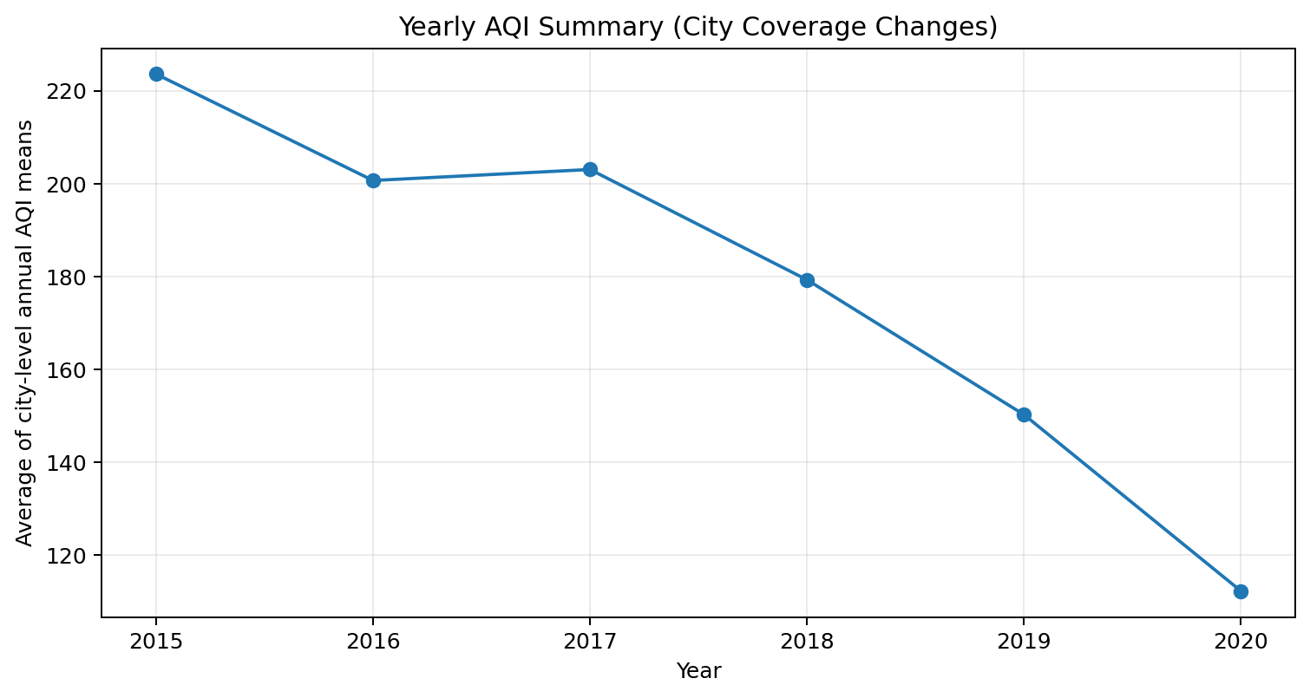
Figure 3. Yearly summary; city coverage changes by year and 2020 is partial.

7.4 Comparison across the same cities
A more comparable analysis used the seven cities represented in every year from 2015 through 2019: Ahmedabad, Bengaluru, Chennai, Delhi, Hyderabad, Lucknow, and Patna. The mean of city-level annual AQI averages was 223.58 in 2015, 210.75 in 2016, 240.50 in 2017, 232.60 in 2018, and 208.26 in 2019. This shows variation across the period and a lower value in 2019 than 2015, but does not establish statistical significance or a national trend.
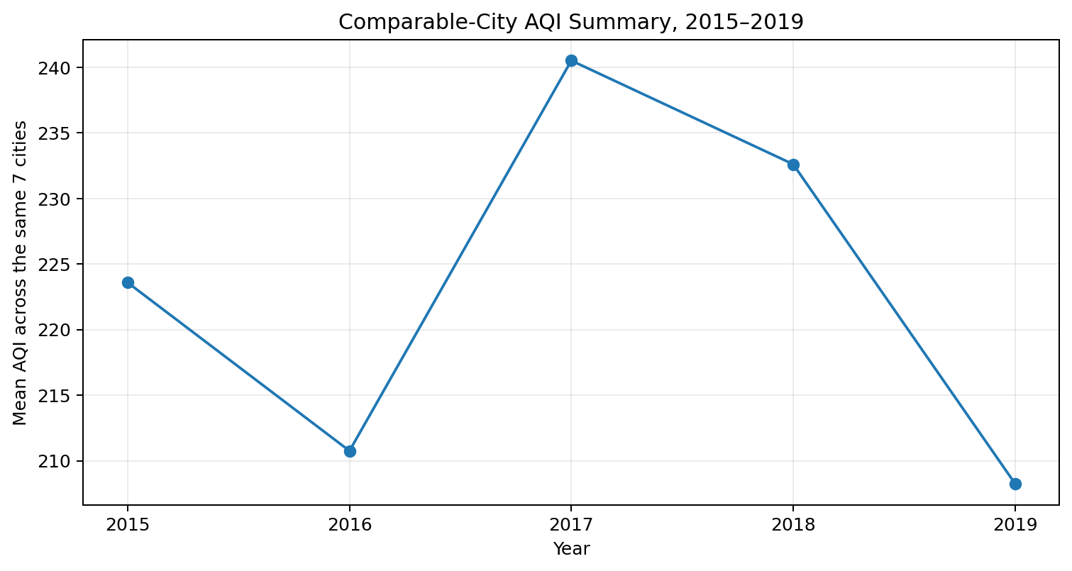
Figure 4. Comparison using the same seven cities, 2015–2019.

7.5 Pollutant correlations
PM10 had the strongest reported correlation with AQI among the selected pollutants (r ≈ 0.803). Other reported correlations were CO 0.68, PM2.5 0.66, NO2 0.54, SO2 0.49, and O3 0.20. Correlations were calculated using available paired observations. Because AQI is derived from pollutant measurements, these associations should not be interpreted as proof of causation.
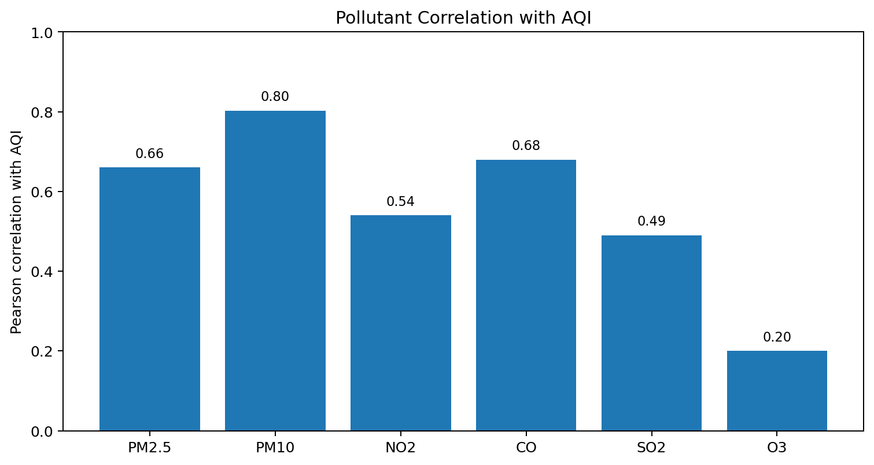
Figure 5. Reported correlation coefficients between selected pollutants and AQI.

8. Limitations
- The analysis is limited to the supplied dataset and its recorded cities/dates; it should not be described as a complete census of air quality across India.
- Missing values may affect city averages, category counts, and correlations. The analysis did not impute missing pollutant or AQI values.
- The number of cities with AQI data differs by year, so yearly summaries are not directly comparable without controlling for coverage.
- The 2020 data ends on 1 July 2020 and represents only part of the year.
- City averages hide variation by season, monitoring location, and individual day.
- Correlation is not causation. AQI is derived from pollutant measurements, so association between pollutant levels and AQI is not independent evidence of causal influence.
- The dataset's license and required attribution should be checked on the source page before publishing the dataset or derived materials publicly.

9. Conclusion
The project demonstrates a reproducible Python workflow for exploring city-level air-quality data: inspection, conservative cleaning, descriptive summaries, visualizations, comparable-city analysis, and correlation analysis. The reported results highlight substantial differences between cities and a strong association between PM10 and AQI in the selected data. Because of missing data, changing city coverage, and the partial 2020 period, conclusions are intentionally descriptive rather than claims about nationwide long-term improvement or pollutant causation.

10. Reproducibility and Project Files
- Project scripts created: 01_data_inspection.py, 02_clean_data.py, 03_exploratory_analysis.py, 04_yearly_analysis.py, 05_fair_city_comparison.py, 06_pollutant_analysis.py.
- Main cleaned file: outputs/air_quality_cleaned.csv.
- Summary outputs include city averages, monthly AQI, category distribution, yearly summaries, fair city comparison, and pollutant correlation tables.
- To reproduce, place the source CSV at data/city_day.csv, install the required Python packages, and run the scripts in numeric order from the project root.

Appendix A: Key Numeric Results
Analysis | Result | Interpretation
Dataset | 29,531 records; 26 cities | 2015-01-01 to 2020-07-01
Highest city average AQI | Ahmedabad: 452.12 | Among the reported city ranking
Most common AQI category | Moderate: 8,829 (35.53%) | Among 24,850 categorized records
Strongest selected pollutant correlation | PM10: r ≈ 0.803 | Association, not causation
Same-city mean, 2015 | 223.58 | Seven cities represented in all years
Same-city mean, 2019 | 208.26 | Descriptive comparison only

